**( الرَّحِيمِ الرَّحْمَٰنِ اللَّهِ بِسْمِ )**

**MOBILE COMPTUING**

**Name : Umer Khan**

**Std Id : BSEF18A020**

**Git Hub:**



**GitHub, Inc.** is a provider of [Internet hosting](https://en.wikipedia.org/wiki/Internet_hosting_service) for [software development](https://en.wikipedia.org/wiki/Software_development) and [version control](https://en.wikipedia.org/wiki/Version_control) using [Git](https://en.wikipedia.org/wiki/Git" \o "Git). It offers the [distributed version control](https://en.wikipedia.org/wiki/Distributed_version_control) and [source code management](https://en.wikipedia.org/wiki/Source_code_management) (SCM) functionality of Git, plus its own features. It provides [access control](https://en.wikipedia.org/wiki/Access_control) and several collaboration features such as [bug tracking](https://en.wikipedia.org/wiki/Bug_tracking_system), [feature](https://en.wikipedia.org/wiki/Software_feature) requests, [task management](https://en.wikipedia.org/wiki/Task_management), [continuous integration](https://en.wikipedia.org/wiki/Continuous_integration) and [wikis](https://en.wikipedia.org/wiki/Wiki) for every project

Git Hub account **: umerk10**

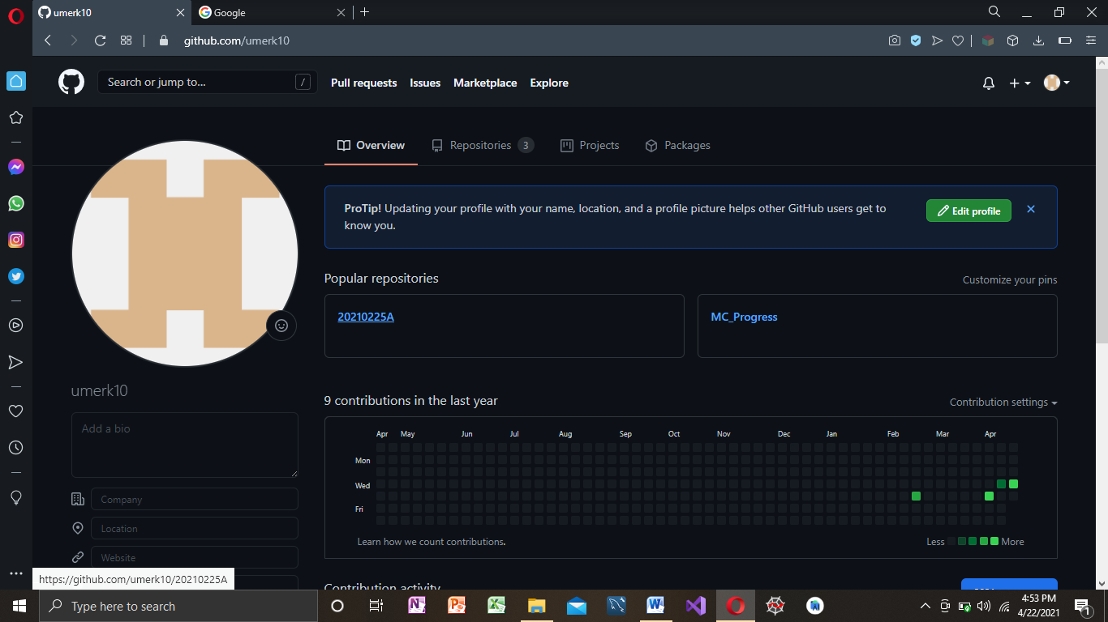

Repsitory Making : https://github.com/umerk10/20210225A.git

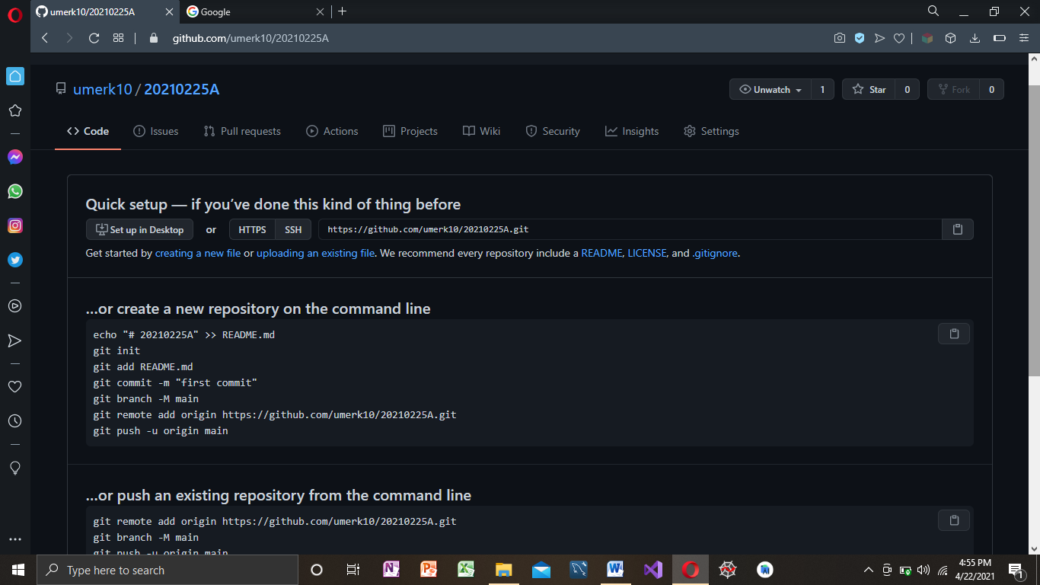

Git clone

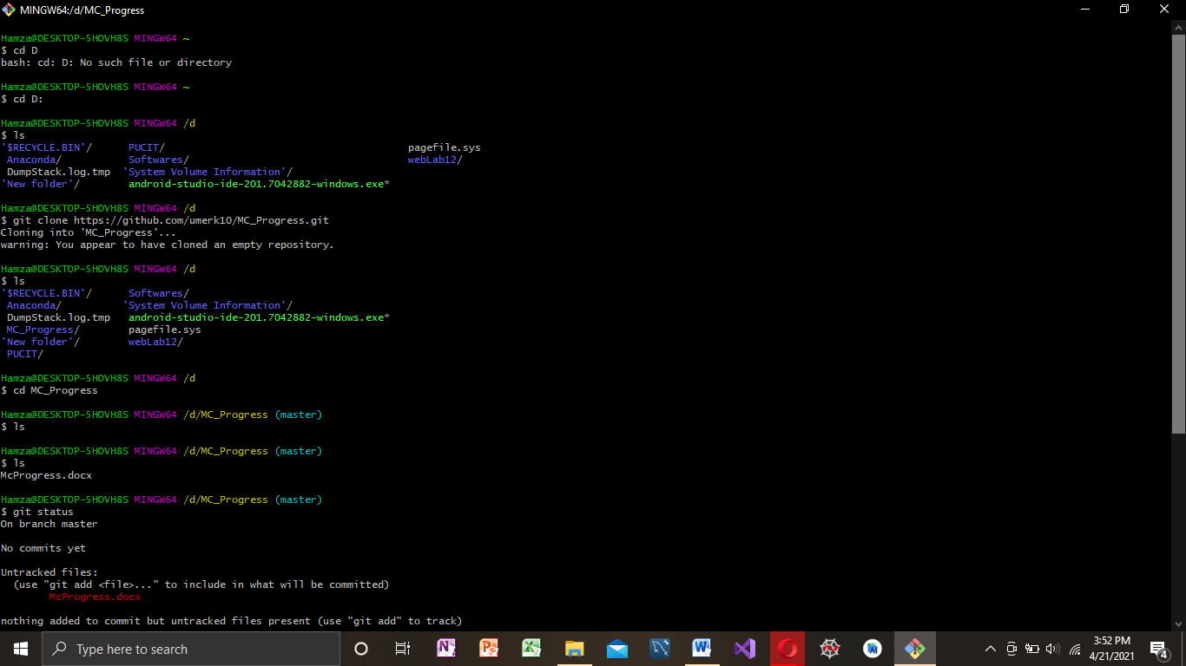

Git Add,Commit,Push,Status:

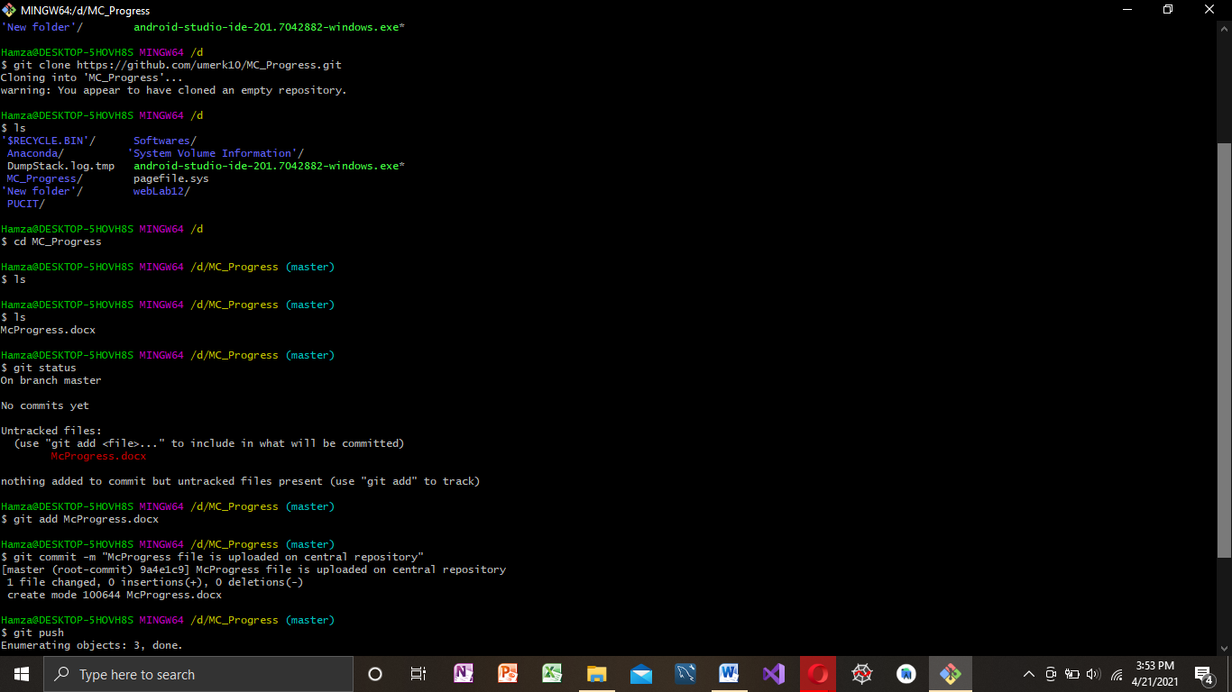

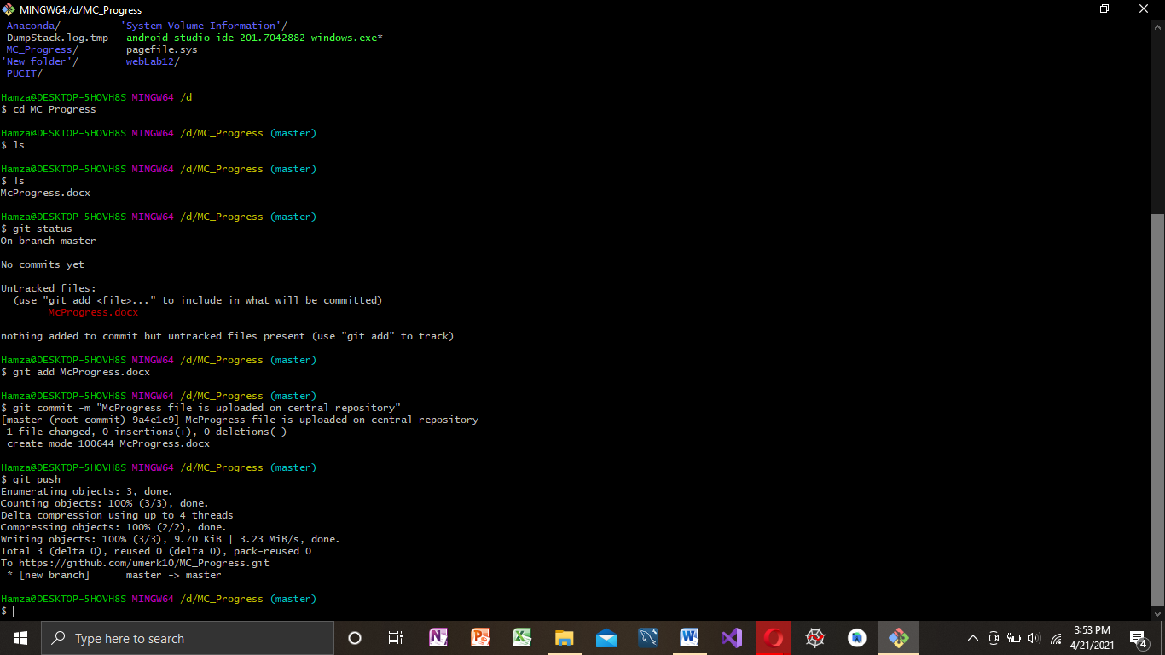

**Andriod Studio:**



**Android Studio** is the official[[7]](https://en.wikipedia.org/wiki/Android_Studio#cite_note-:0-7) [integrated development environment](https://en.wikipedia.org/wiki/Integrated_development_environment) (IDE) for [Google](https://en.wikipedia.org/wiki/Google)'s [Android](https://en.wikipedia.org/wiki/Android_(operating_system)) [operating system](https://en.wikipedia.org/wiki/Operating_system), built on [JetBrains](https://en.wikipedia.org/wiki/JetBrains" \o "JetBrains)' [IntelliJ IDEA](https://en.wikipedia.org/wiki/IntelliJ_IDEA" \o "IntelliJ IDEA) software and designed specifically for [Android development](https://en.wikipedia.org/wiki/Android_software_development).[[8]](https://en.wikipedia.org/wiki/Android_Studio#cite_note-8) It is available for download on [Windows](https://en.wikipedia.org/wiki/Windows), [macOS](https://en.wikipedia.org/wiki/MacOS" \o "MacOS) and [Linux](https://en.wikipedia.org/wiki/Linux) based operating systems or as a subscription-based service in 2020.[[9]](https://en.wikipedia.org/wiki/Android_Studio#cite_note-9)[[10]](https://en.wikipedia.org/wiki/Android_Studio#cite_note-10) It is a replacement for the [Eclipse Android Development Tools](https://en.wikipedia.org/wiki/Eclipse_(software)#Android_Development_Tools) (E-ADT) as the primary IDE for native Android application development.

onClick Function:

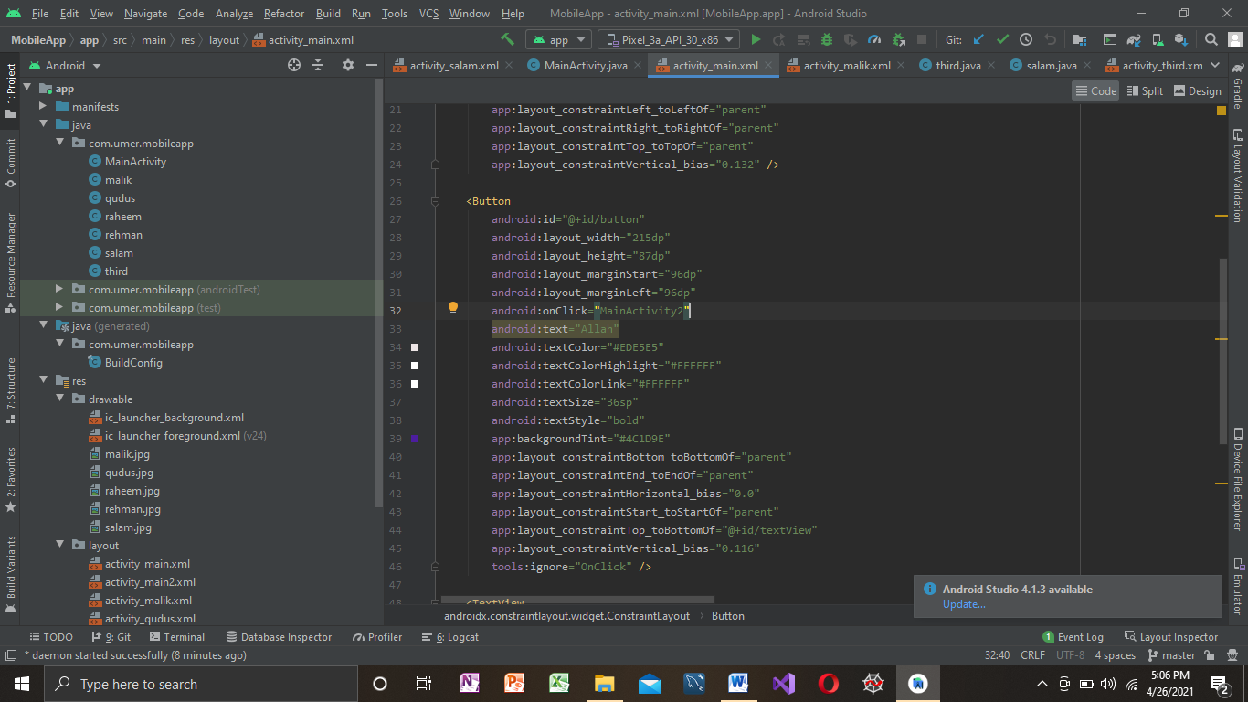

Intent:

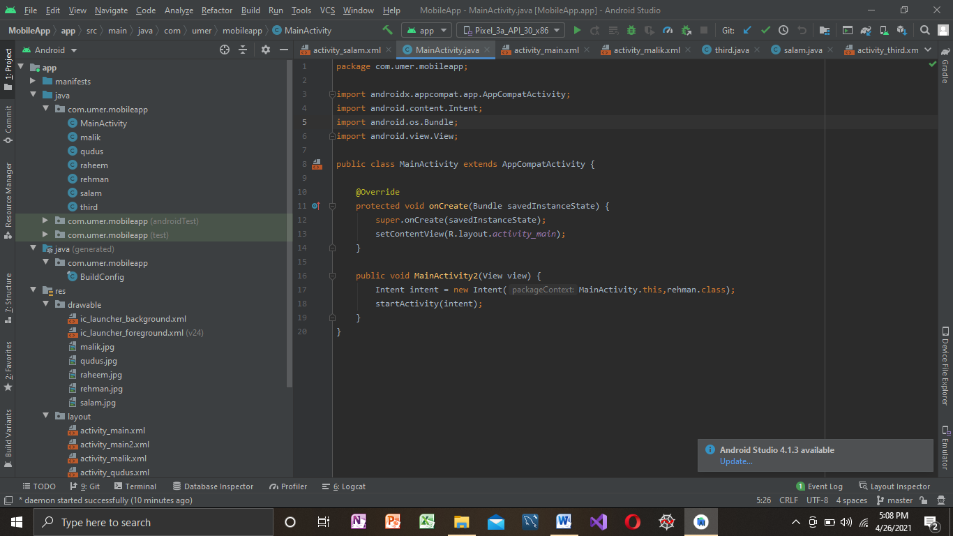

Animation:

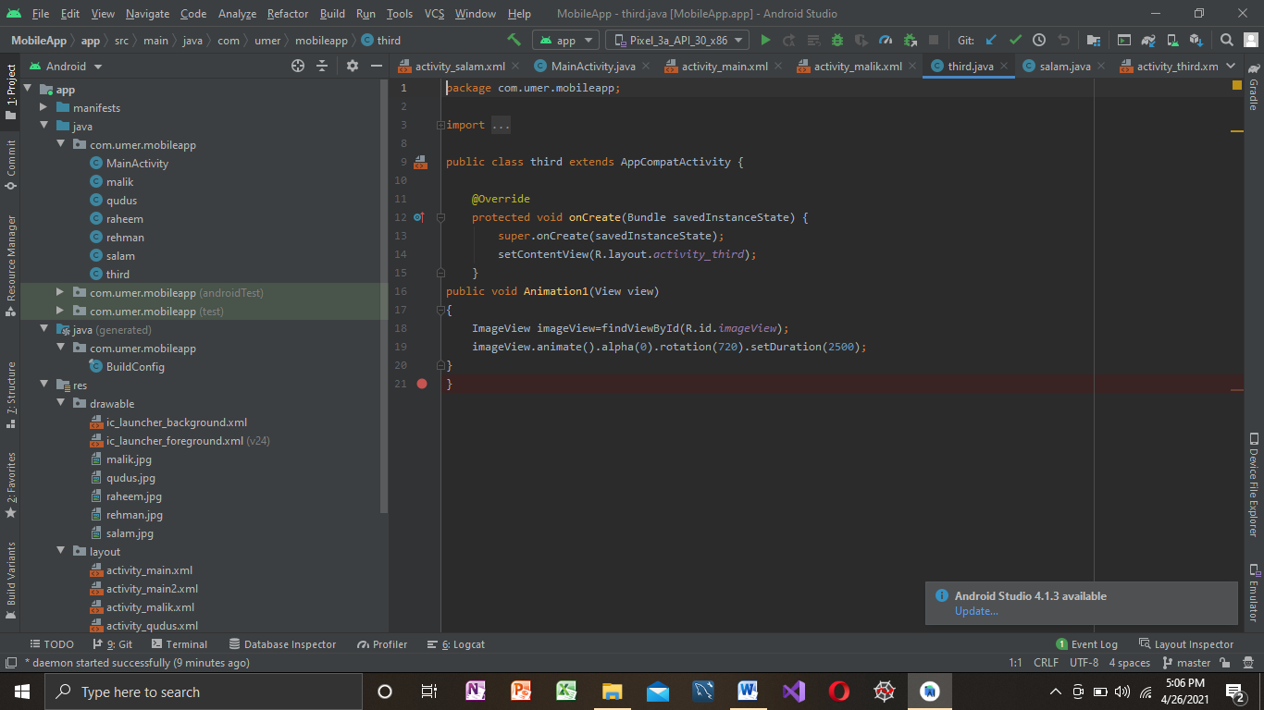

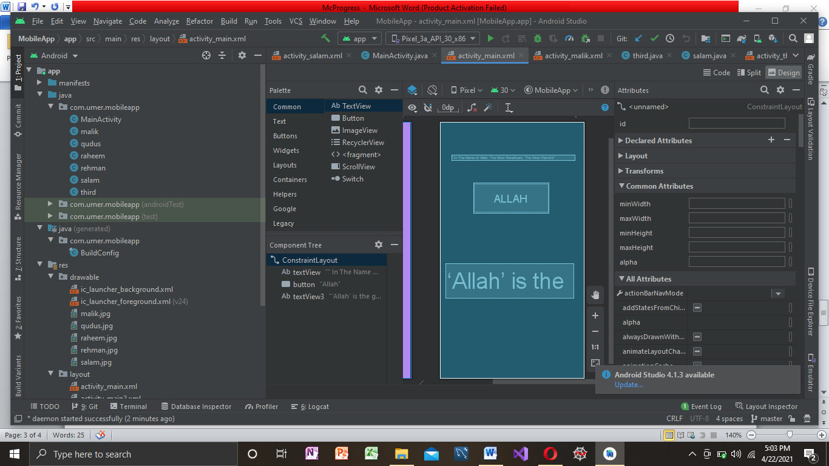

Basic Mobile Application:

 Video of basic app